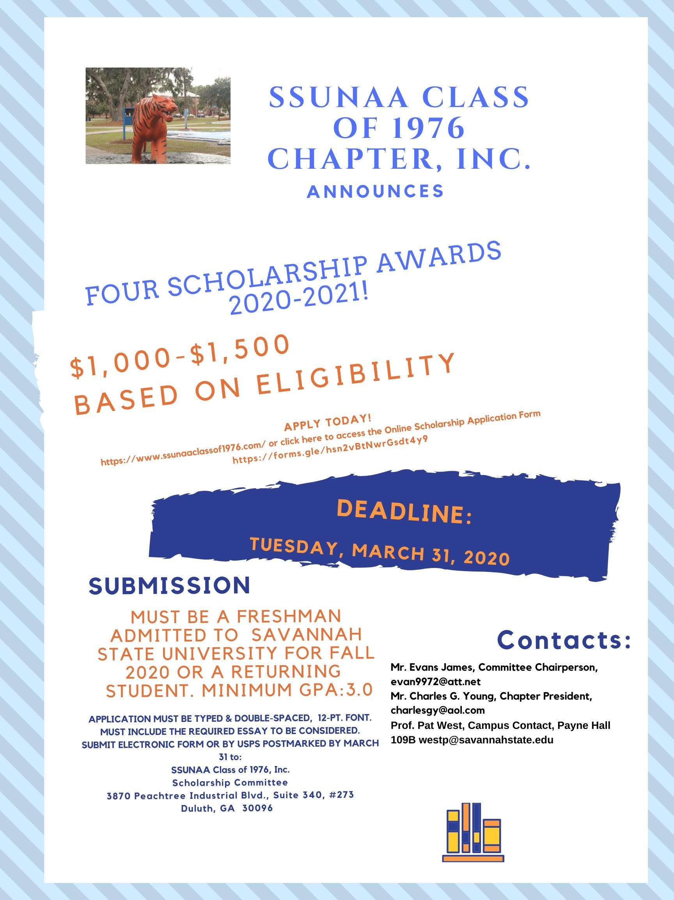

“SSUNAA --CLASS OF 1976 CHAPTER” SCHOLARSHIP MAIL-IN APPLICATION FORM
Must be typed
SAVANNAH STATE UNIVERSITY 2020-2021
NAME__________________________________________________________________
SSU 915 ID_____________________________________________

EMAIL ADDRESS_____________________________________________________________________
CHECK ONE: _____ENTERING FRESHMAN FALL 2020 ____ CONTINUING IN GOOD STANDING
CLASSIFICATION_______________________________
HOME STREET ADDRESS______________________________________________________
CITY, STATE, ZIP ____________________________________________________________
TELEPHONE _____________________________________ DATE OF BIRTH__________________
PARENT’S NAME _________________________________________ TELEPHONE______________
PARENTS' ADDRESS, City, State, Zip (If different)__________________________________________________________________________________________________________________________________________________________________
HIGH SCHOOL _________________________________________________________________________
SCHOOL ADDRESS, CITY/STATE ___________________________________________________________
PRINCIPAL/ACADEMIC ADVISOR __________________________________________________________
GUIDANCE COUNSELOR _________________________________FRESHMAN HIGH SCHOOL GPA _______
ACADEMIC ADVISOR_______________________________________ CONTINUING STUDENT GPA___
NAME OF COLLEGE IF OTHER THAN SSU_____________________________________________________
COMPOSITE SAT/ACT SCORE____________ MATH SCORE____________ VERBAL SCORE ________
COMMUNITY SERVICE HOURS________________
ORGANIZATIONS SERVED_______________________________________________________________________________
HONORS, AWARDS, RECOGNITION___________________________________________________________________________________________________________________________________________________________________________________________________________________________________________________
SCHOOL, COMMUNITY, FAITH-BASED ACTIVITIES? ___________________________________________
DECLARED OR PROBABLE MAJOR? ________________________________________________________
ANNUAL HOUSEHOLD INCOME (SEE FAFSA FORM)___________________NUMBER IN HOUSEHOLD ____

SIGNATURE_____________________________________________ DATE ____________________
PARENT’S SIGNATURE (If applicable)________________________________________________________ DATE ______________

ESSAY PROMPT: MY GOALS AND HOW SAVANNAH STATE UNIVERSITY WILL HELP ME TO ACHIEVE THEM (2 pages)

